6-PLANT

This module plants the vegetation layers and selects the species of tree to be planted in a cohort. Once a cohort is created by a disturbance, each of four vegetation layers is planted and an age-structure is created as determined by the colonization rate of that vegetation (i.e., plant) layer. The species within the tree layers is also determined by PLANT and depends on the light requirements, climate (temperature and moisture), and local seed abundance.

The files directly required by this module are Estab.prm and TreeReg.prm.

PlantChort Function.

The purpose of this function is to plant the vegetation layers once a cohort has been formed. Cohorts are created by disturbances that kill all the vegetation in part or all of a stand grid cell. The proportion of standgrid cell area allocated to a cohort depends on the amount of a stand grid cell that is killed. If the entire stand grid cell is killed, then the next cohort potentially occupies 100% of the stand grid cell area. If half the stand grid cell is killed, then the next cohort occupies 50% of the stand grid cell area, and so on. When a life form or tree species is planted in a cohort, then the life form and species specific growth, mortality, and decomposition parameters are imported into the Growth, MORTALITY and Decompose modules for that cohort. This starts the processes of growth, mortality, and decomposition within the cohort.

Plant layers (i.e., herb, shrub, upper trees and lower trees) have unequal chances of colonizing a cohort. The probability a layer will be planted is defined in the Estab.prm file by a mean rate and a standard deviation of colonization. Upper trees can be colonized either naturally or artificially. It is assumed that herbs, shrubs, and lower trees colonize naturally. In addition, lower trees have a lag before they establish in part because upper trees must establish first, and in part because of dispersal. The establishment rate is used to create an age-class structure based on the upper layer in a cohort assuming the area left for colonization is a negative exponential function (Figure 6-1):

Remaining Area for Colonization= exp[-ColonizationRate* TimeSinceCohortFormation]

The area of each age-class is solved by substracting the remaining area for colonization of the current age-class from that of the preceeding age-class. Note that with this function the different age-classes occupy different proportion of the cohort space. We assume that herb and shrub layers will colonize faster than tree layers and therefore use the upper tree layer ability to colonize to determine if additional cohorts will be required. Therefore the upper layer has a limited period in which to colonize the space allocated to a cohort; if the colonization rate is too slow to colonize the entire cohort area in the allotted time, then a new cohort is established on the remaining area. The assumption is that age-classes within cohorts are roughly similar in terms size and that if too much time elapses this would no longer be the case. If a additional cohorts are required to fill the space created by the disturbance, then age-class distributions for all the plant layers are created. However, the tree layers are not
actually initialized until the lags associated with their establishment are exceeded. This allows the non-tree layers to grow unimpeded until trees actually establish in the cohort. For lower trees the age-class structure is created at the same time as the upper trees, but the lower tree species is not determined until this establishment lag time is exceeded.
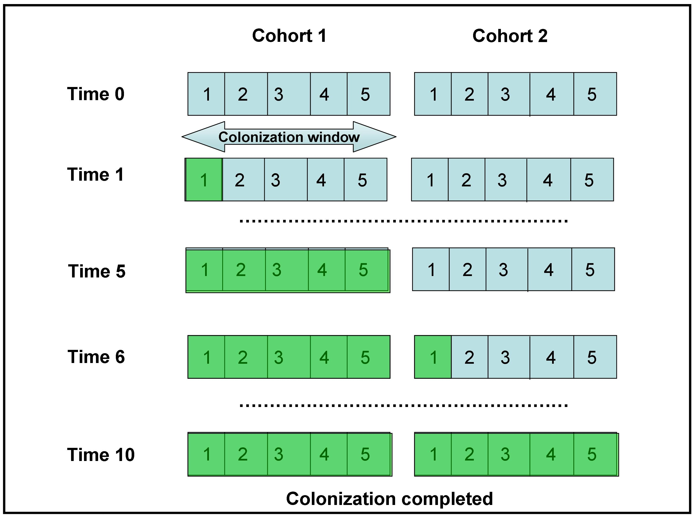

Figure 6-1. Hypothetical example of how cohorts are colonized by trees. The colonization window is the time limit allowed for a cohort to fill. If it is exceeded then a new cohort is established. This keeps trees within a cohort relatively similar in size.

When a layer planted, then a message is sent to Growth module to make the mass of foliage for that layer a small positive number. Once the foliage mass is added the layer begins to grow and add biomass. Adjusting InitialFoliageMass (the value is specified in the GrowLayer.prm file) determines the length of time lag required for the layer to begin growing at a significant rate. Setting this parameter low increases the lag time, whereas increasing it decreases the lag time. Note that for lower trees and upper trees in additional cohorts, the initial foliage mass is not changed to a small positive number until their establishment lag times are exceeded.

PlantTree Function.

In LANDCARB trees are treated on the species level. The PlantTree function selects which species can be planted. LANDCARB does not consider all the factors that control tree establishment. Rather the intent of the PlantTree function is to plant trees in proportion to their abundance and so as to mimic the presence of an early and late successional tree species.

The first step is to determine the local abundance of tree species. This is a function of the tree species present in cohorts within the stand grid cell being examined as well as those present in the adjacent stand grid cells. The user defines a seed source area to be considered which determines how many stand grid cells are considered. The user also defines the degree a species can produce seeds in the SeedSource.prm file in various source zones. Species are randomly selected for planting based on their abundance, however, to be planted a tree species must fall within limits of light, temperature, and soil moisture as defined in the TreeReg.prm file.

To select a tree species the PlantTree function first eliminates all the species that do not fall within the light, temperature, and moisture limits (Figure 6-2). It then determines the proportion of seeds available based on the results of the Seed Dispersal Module. Tree species are then selected in proportion to their abundance.

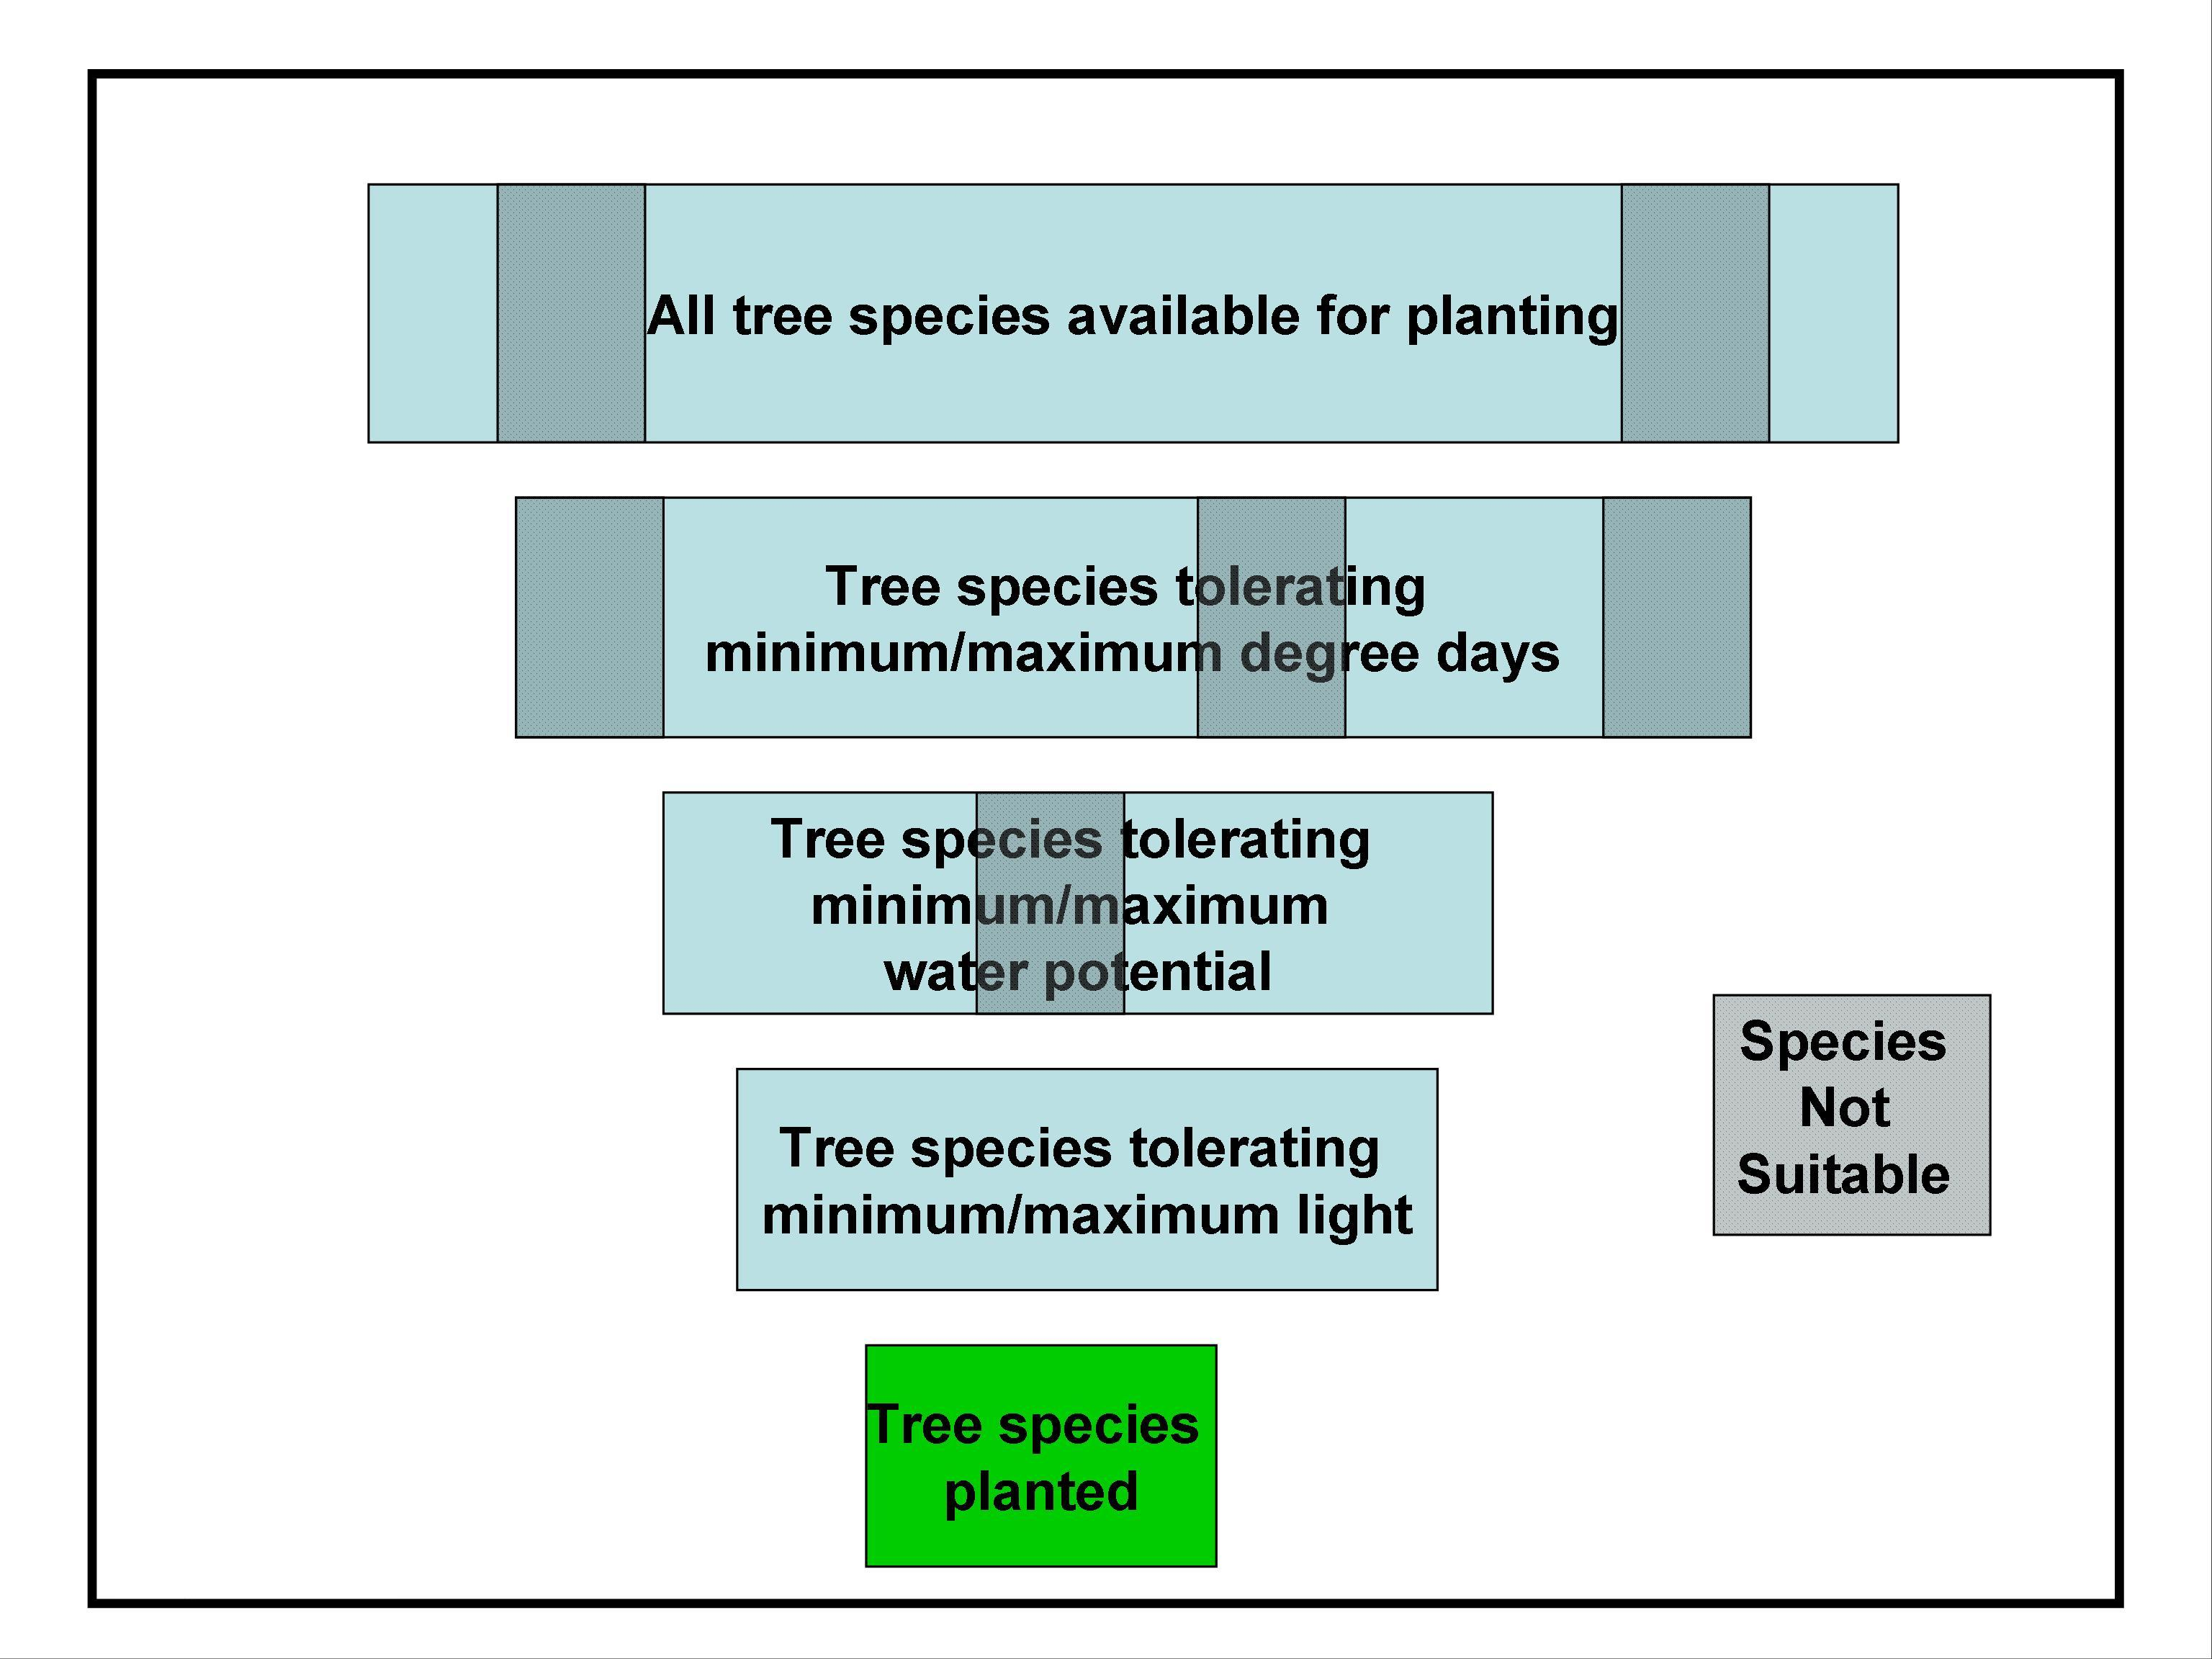

Figure 6-2. Conceptual diagram of how all available tree species are filtered to those actually planted in a cohort.

Temperature Limits. A species may not be planted if the thermal environment of the site exceeds the limits of a tree species. If the degree day values (DDays) of a site determined from the DegreeDays function of the Climate module are equal to or below the degree day minimum (DDayMin), or equal to or exceed the degree day maximum (DDayMax) for a species, then its probability of establishment is set to zero (DDayLimit). If the DDays are within the limits then DDayLimit is set to one.

Soil Moisture Limits. A species of tree may also not be planted if the site is too dry or too wet. For these calculation we use the absolute value of soil water potential as a indicator of soil moisture. (Note: when using soil water potential the wettest soil has the lowest water potential and the driest soil has the highest water potential). If the yearly maximum soil water potential (MaxMonWaterPot) calculated for a stand grid cell in the WaterPot function of the Climate module is equal to or lower than the species minimum (TreeSoilMax), then the value of SoilLimit is set to zero. If the soil water potential exceeds the species minimum (TreeSoilMin) for more than a specified number of months, then SoilLimit is also set to zero. If the site soil water potential is within these limits, then SoilLimit is set to one.

Light Limits. A species of tree may not be able to establish within a cell if there is too much or too little light. In the former case, light per se may not be the limiting factor. Excessive heating or drying may be the actual mechanism involved. These problems are highly correlated, however, to high light levels. Minimum light levels are related to the species shade tolerance and light compensation point.

The light value used to determine whether a tree species can establish depends upon whether it is being planted as an upper tree or as a lower tree layer. For upper trees the value of light that is considered is the amount entering a cell (UpperTreeLightIn). This may fall below full sunlight if adjacent cohorts and stand grid cells contain taller trees that shade the cohort being considered (see Neighbor module). For lower trees the value of light used is the amount of light leaving the upper tree layer (LowerTreeLightIn) at the time the lower tree establishment lags are exceeded. If the light value considered in either case is equal to or within the limits during the time step a species is being selected, then the value of LayerLightLimit is set to 1. If the light exceeds the maximum and minimum light limits, then the value of LayerLightLimit is set to zero.

